Experiment – 8
Write a program to implement Linear Regression (LR) algorithm in python

Aim
To implement the Linear Regression (LR) algorithm in Python using Scikit-learn and predict continuous values from a dataset using Google Colab.

Algorithm
- Import the required Python libraries.
- Load a regression dataset.
- Split the dataset into training and testing sets.
- Create a Linear Regression model.
- Train the model using the training dataset.
- Predict the output values for the test dataset.
- Evaluate the model using Mean Squared Error (MSE) and R² Score.
- Display the regression coefficients and intercept.
- Interpret the performance of the model.
Program:
# Step 1: Import Libraries
import numpy as np
import pandas as pd

from sklearn.datasets import fetch_california_housing
from sklearn.model_selection import train_test_split
from sklearn.linear_model import LinearRegression
from sklearn.metrics import mean_squared_error, r2_score

# Step 2: Load Dataset
housing = fetch_california_housing()

X = housing.data
y = housing.target

# Step 3: Split Dataset
X_train, X_test, y_train, y_test = train_test_split(
X, y, test_size=0.2, random_state=42
)

# Step 4: Create Linear Regression Model
model = LinearRegression()

# Step 5: Train Model
model.fit(X_train, y_train)

# Step 6: Predict
y_pred = model.predict(X_test)

# Step 7: Evaluate Model
mse = mean_squared_error(y_test, y_pred)
r2 = r2_score(y_test, y_pred)

print("Regression Coefficients:")
print(model.coef_)

print("\nIntercept:")
print(model.intercept_)

print("\nMean Squared Error (MSE):", mse)
print("R² Score:", r2)

# Display some predictions
results = pd.DataFrame({
'Actual': y_test[:10],
'Predicted': y_pred[:10]
})

print("\nSample Predictions:")
print(results)
Output:
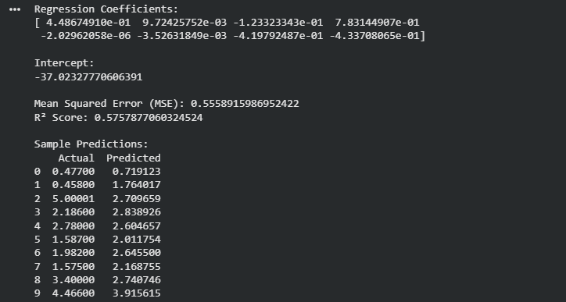
Result:
The Linear Regression algorithm was successfully implemented in Python using Scikit-learn. The model was trained on the California Housing dataset and used to predict continuous target values. The performance was evaluated using Mean Squared Error (MSE) and R² Score, demonstrating the effectiveness of the Linear Regression model for regression tasks.

